Q1. Create Database
Command
create database sales;
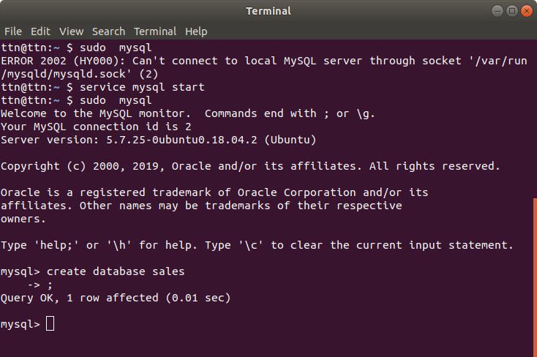

Q2. Design Schema
Solution
Assumptions
--> 1 sales person can have only one contact number
--> 1 customer can have only one contact number
-->Orders ifanalyzed will be done on basis of date, not time stamp.
Facts
-->1 customer can have multiple orders, but one order id will be associated with only single customer. Therefore, customer and orders have 1 to many relationship.
-->1 order will have one sales person, but 1 sales person can have multiple orders. Therefore, sales person and order have one to many relationship
-->1 order can have multiple items and one item can be a part of multiple orders. Therefore, order and item have many to many relationship.
Schema design
Customers (#cust_id int,cust_name varchar ,phone bigint,email varchar,passwd varchar,address varchar)
Item(#item_id int,item_name varchar,price float,color varchar,stock_available int)
SalesPerson(#sp_id int,name varchar,phone bigint,address varchar,salary float)
OrderCustomerMap(#order_id int,customer_id int references customers,date date,total_amt float,sp_id int references SalesPerson)
OrderItemMap(#oimap_id int,order_id int references OrderCustomerMap,item_id int references Item,quantity int,total float)

Note: #--primary key

Q3 . Create tables.
Commands
create table customers(cust_id int primary key AUTO_INCREMENT,cust_name varchar(200 ),phone bigint,email varchar(100) NOT NULL,passwd varchar(100) NOT NULL,address varchar(300));

create table item(item_id int primary key AUTO_INCREMENT,item_name varchar(100),price float,color varchar(100), stock_available int);
Query OK, 0 rows affected (0.29 sec)

create table sales_person(sp_id int primary key AUTO_INCREMENT,name varchar(100),phone bigint,address varchar(200),salary float);

create table order_customer_map(order_id int primary key AUTO_INCREMENT,cust_id int references customers,date date,total_amt float,sp_id int references sales_person);

create table order_item_map(oimap_id int primary key AUTO_INCREMENT,order_id int references order_customer_map,item_id int references item,quantity int, total float);
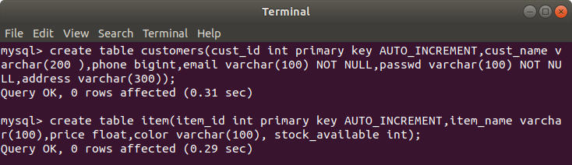
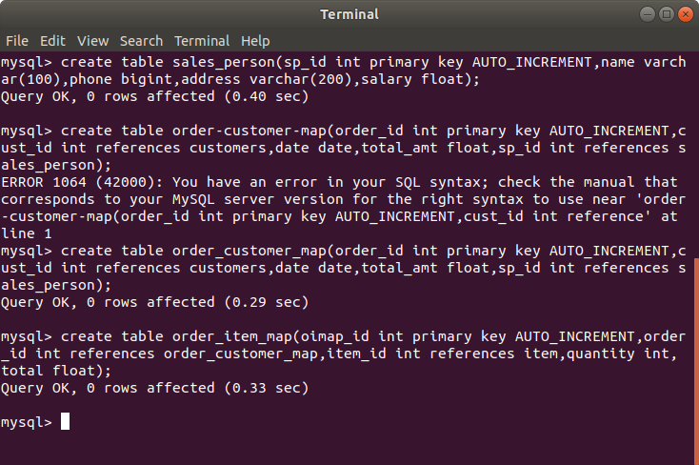

Q4. Insert sample data
Commands
insert into customers(cust_name,phone,email,passwd,address)values('surbhi',9873324663,'surbhi.garg@tothenew.com','abc@123','janakpuri'), ('abhinav',9854012345,'abhinav.srivastava@tothenew.com','abhinav@123','noida'), ('vagish',9821345622,'vagish.dixit@tothenew.com','dixit','rajouri');

insert into item(item_name,price,color,stock_available)values('jacket',3000,'red',20),
('trousers',1500,'navy-blue',10),
('graphic-tee',1000,'black',20);

insert into sales_person(name,phone,address,salary)values('shubham',9999888812,'vikaspuri',15000),
('lohit',8899123456,'yamuna bank',12000),
('arpit',8989127812,'cp',7000);

insert into order_customer_map(cust_id,date,total_amt,sp_id)values (1,'2019-01-03',3000,1), (1,'2018-03-05',1500,1),
(2,'2018-02-01',1000,2),
(3,'2018-03-02',3000,2),
(2,'2018-05-01',1500,3);

insert into order_item_map(order_id,item_id,quantity,total)values(1,1,1,3000),
(2,2,1,1500),
(3,3,1,1000),
(4,1,1,3000),
(5,2,1,1500);

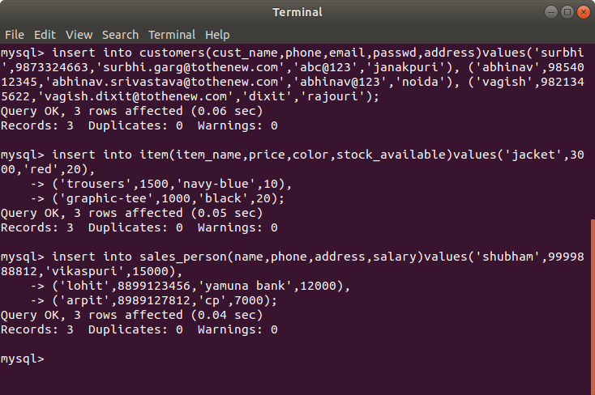
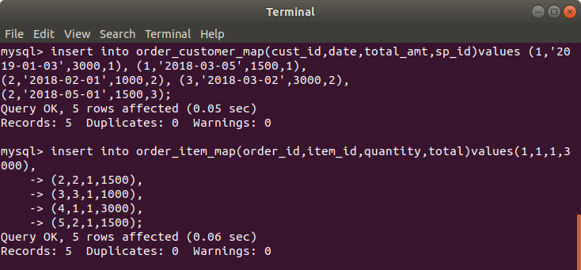
Table data
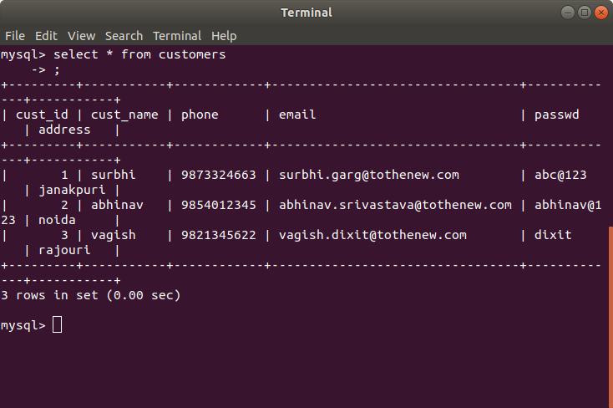
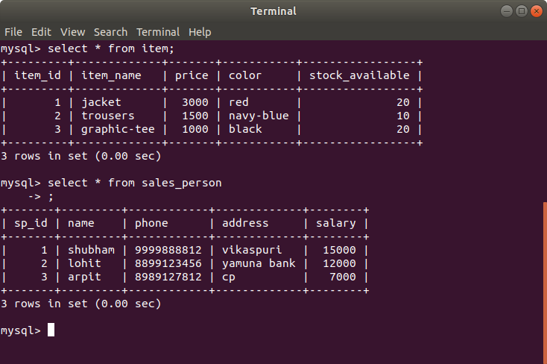
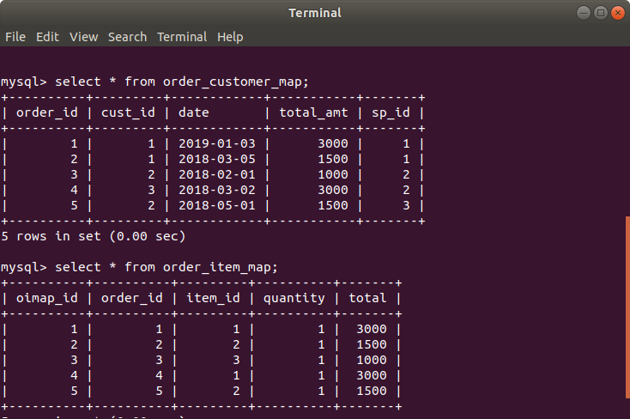

Q5. Find the sales person have multiple orders.
Command
select sp.sp_id,name from sales_person sp join order_customer_map ocm on sp.sp_id=ocm.sp_id group by sp.sp_id having count(order_id)>1;

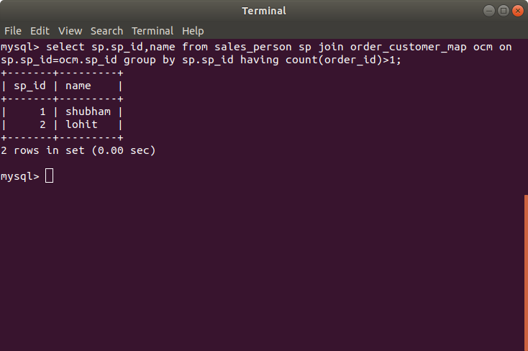

Q6. Find the all sales person details along with order details
Command
select sp.sp_id,name,ocm.cust_id,ocm.total_amt,oim.item_id,oim.quantity from sales_person sp inner join order_customer_map ocm on sp.sp_id=ocm.sp_id inner join order_item_map oim on ocm.order_id=oim.order_id;
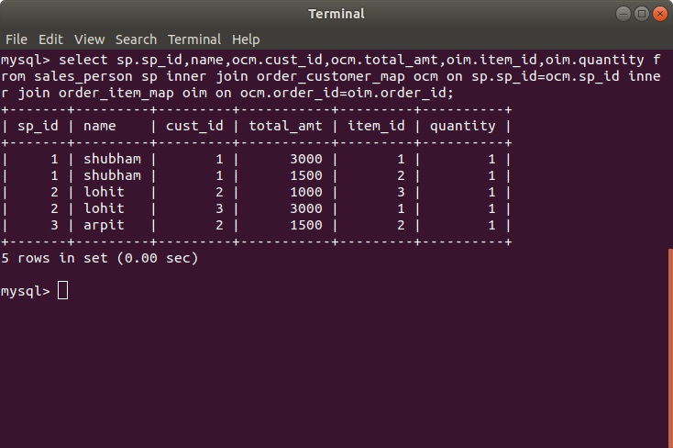

Q7. Create index.
Command
alter table order_customer_map add index sp_id(sp_id);
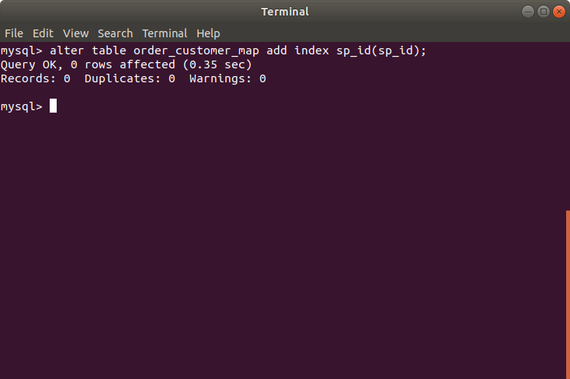
Q8. How to show index on a table
Command
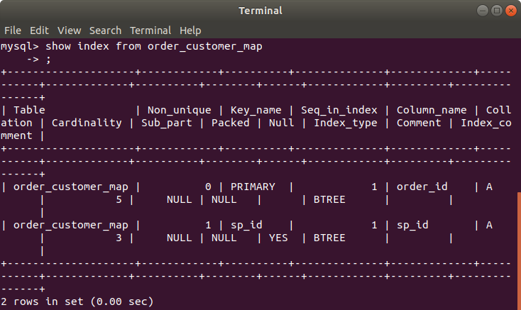
show index from order_customer_map;

Q9. Find the order number, sale person name, along with the customer to whom that order belongs to.
Command
select ocm.order_id,sp.name,cust.cust_name from order_customer_map ocm join sales_person sp on ocm.sp_id=sp.sp_id inner join customers cust on ocm.cust_id=cust.cust_id;
